LAB 1: Introduction to Networking

Contents

How to use the lab guides 2

Introduction to LAB 1 2

Exercise 1: Explore, download and install Cisco Packet Tracer 2

# How to use the lab guides

The lab guides in this training are designed to be completed in class or at home. This means that depending on your time and availability, you can accomplish the tasks in each lab either during (after) the corresponding lecture, use it as a homework or split it for class/home work as you wish. Important is that you are finished with each lab before the date of the next lecture.

Note: You do not have to send or submit your labs as homework or project, and they will not give you additional points for the exam. Still, if you need to really understand the topics (and help yourself for the exam), it is highly recommended that you do them regularly and in a timely manner.

# Introduction to LAB 1

In this first LAB, you will be asked to download and install Cisco Packet Tracer and to spend some time learning how to use it. This simulator will be your primary tool for practicing with network configuration commands, protocols, and configurations.

# Exercise 1: Explore, download and install Cisco Packet Tracer

In this exercise, you are going to do the following:

* Register an account at **Skills For All**
* Watch the online course to learn how to work with it
* Download and install the **Cisco Packet Tracer** simulator on your computer

1. Navigate to <https://skillsforall.com/>
2. Scroll to the bottom of the page and click on **Join Today**

1. Click on **Sign up** and follow the steps to create an account. Accept the Terms & Conditions and click **Accept & Continue**

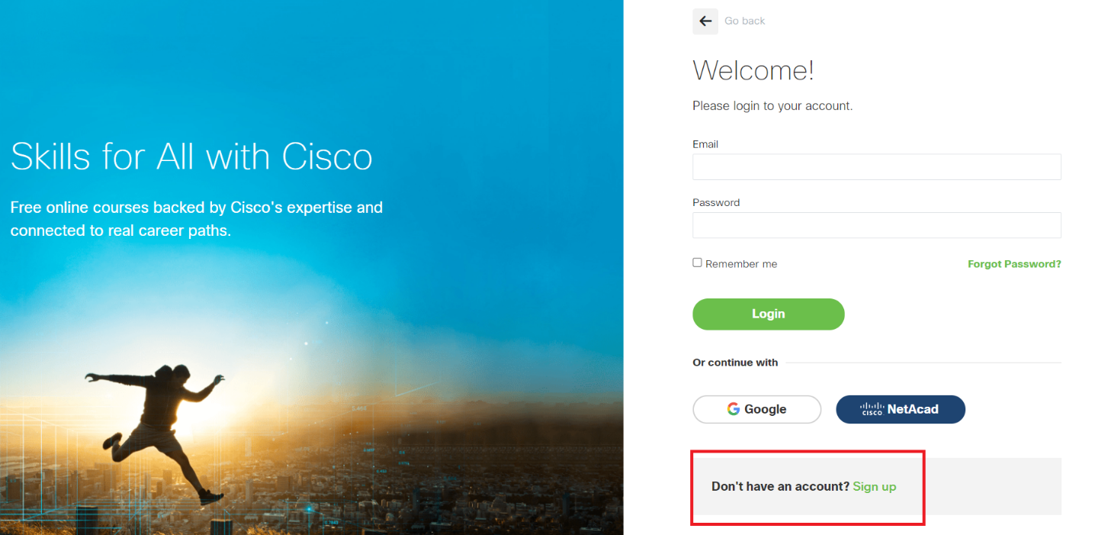

1. When you register and login, you will be presented the **My Learning** page. Click on **Browse catalog**

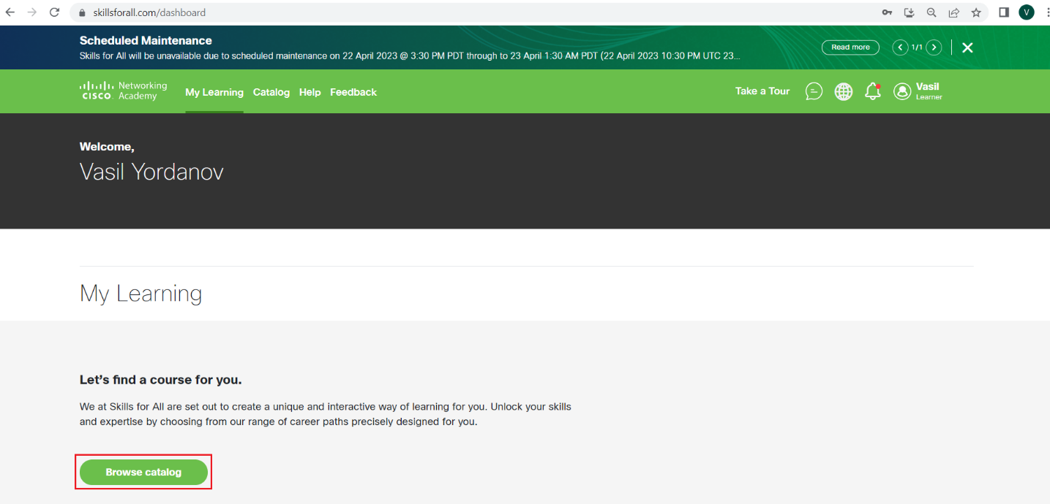

1. In the **Learning Catalog**, you have to find the **Getting Started with Cisco Packet Tracer** course. To make this easier, filter by selecting **Course** in the **Category** section and also select **Beginner** in the **Level** section. When you find the course, click on it to open it

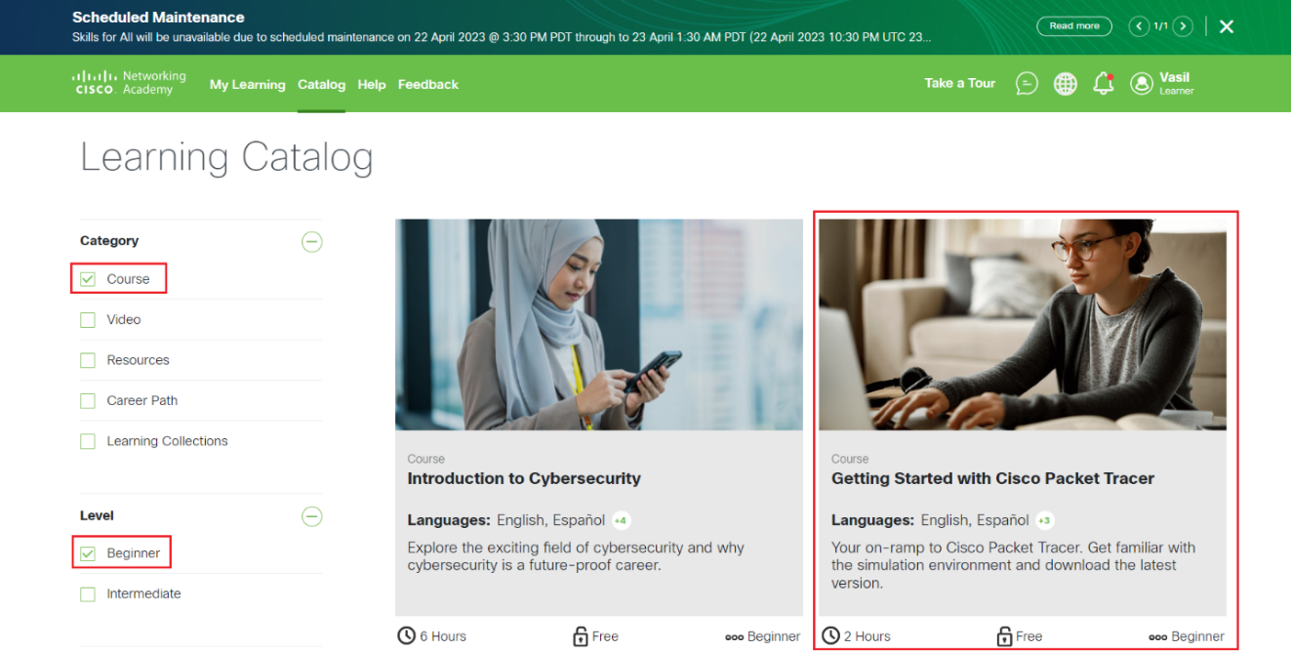

Depending on the page interface, maybe you will have a different view. For example, it can be in the **Explore** section, where you can find the **Cisco Packet Tracer** course

1. Click on **Get Started** to launch the course

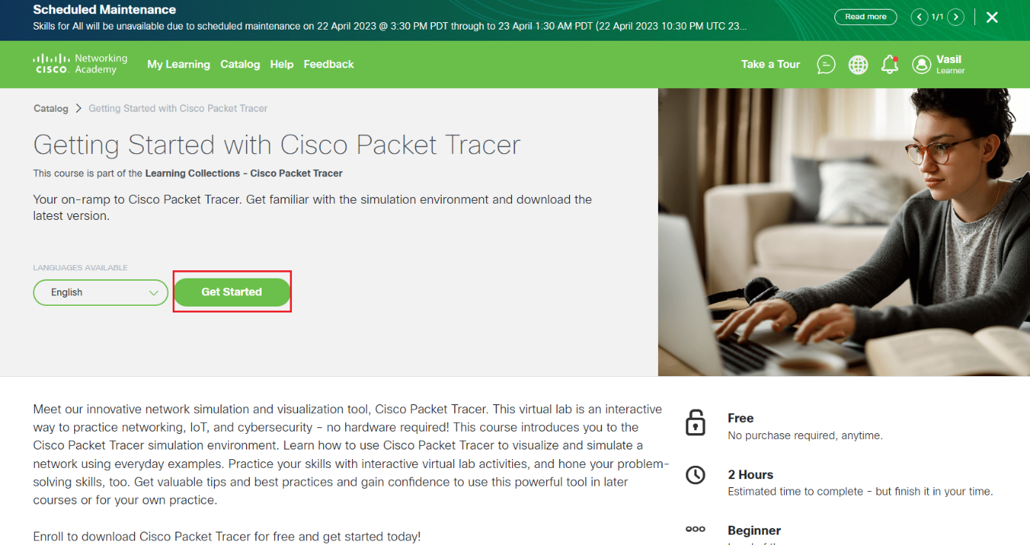

1. Inside the course, navigate to **Download and Use Cisco Packet Tracer** and then **1.0. Install Cisco Packet Tracer**.

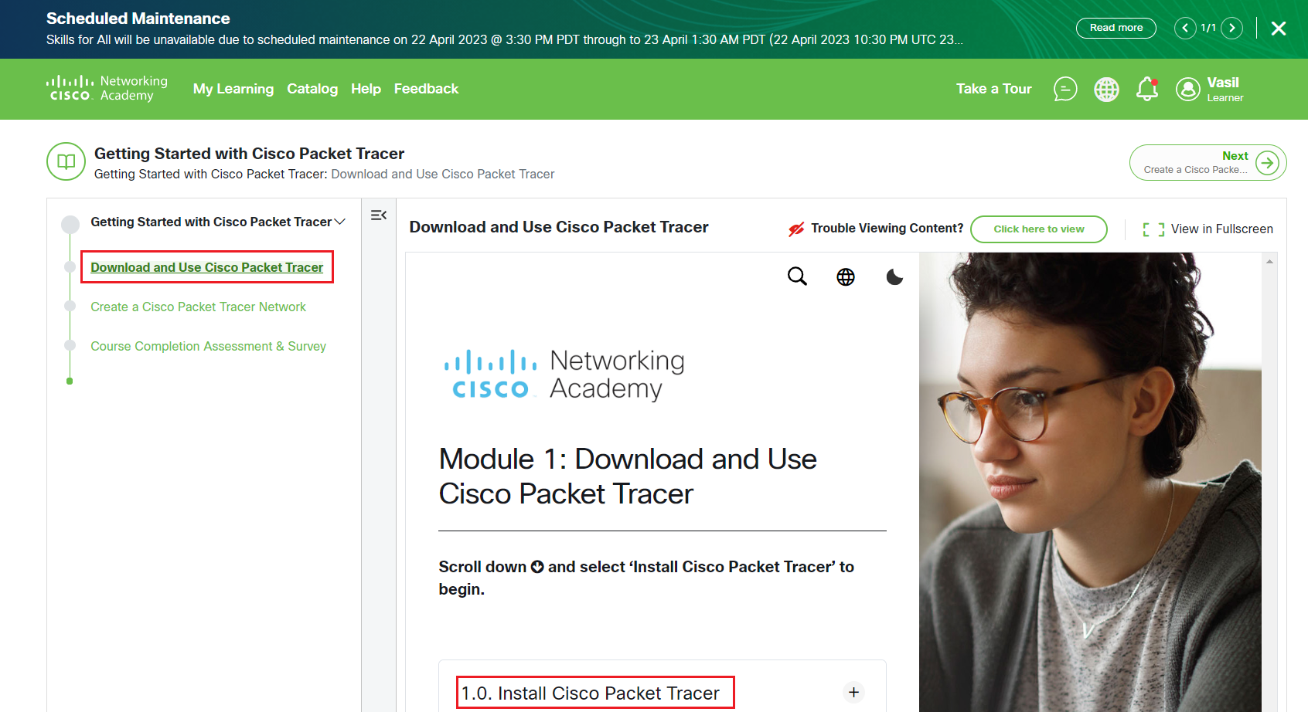

1. Scroll down until you find the download link

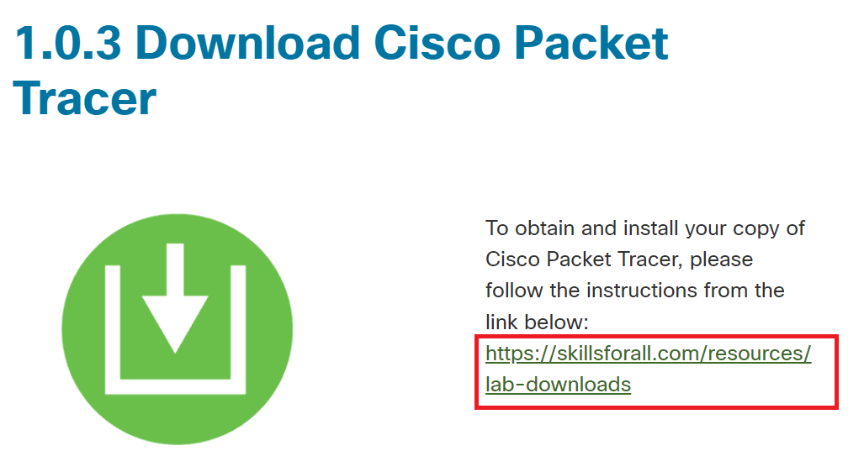

1. Click on the link from the screenshot above (it is [this one](https://skillsforall.com/resources/lab-downloads), but you have to be logged in) and you will see the links for downloads

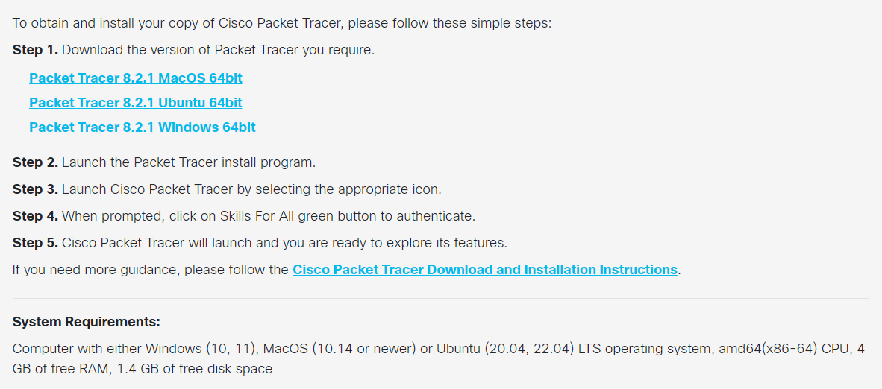

1. Download the appropriate version for you (we recommend the Windows version, if you have multiple platforms) and install it on your computer
2. If you receive a firewall security alert (for the Windows installations), click on **Allow access**
3. First time you run the simulator, you may receive a **Would you like to run multi-user when application starts?** question. We are not going to use this feature, so you can answer with **No**

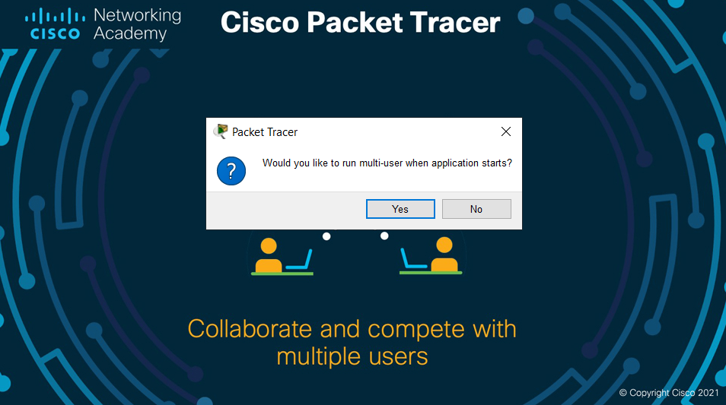

Note: Although you have already downloaded a copy of the software and installed it locally, you still need to login with your **Skills For All** account when you use it. That is why having an account is not optional.

1. You should now have installed and logged in to Cisco Packet Tracer. Please have a look around and play with it by adding devices and connecting them. In the next lab, we will start building topologies and explore different protocols for communication.
2. [Optional] Return to the **Getting Started with Cisco Packet Tracer** course and review the materials (text and video) to get familiar with the simulator
3. [Optional] You may want to also register an account in [Cisco Networking Academy](https://www.netacad.com/). The idea is that this account can be used as a backup authentication method in the cases when **Skills For All** site is unavailable, for example due to scheduled maintenance. To do this, go to **Log In** -> **Login** in the top right and then select **Sign up**

You have completed LAB 1.